AUGUST NEWSLETTER

Can you believe that school is almost already here? It’s crazy how fast it flies....... It is one of the best parts of my job, watching your children get bigger and bigger. I am looking forward to serving you all again and thank you for letting me be a part of your Rascals lives again this year!
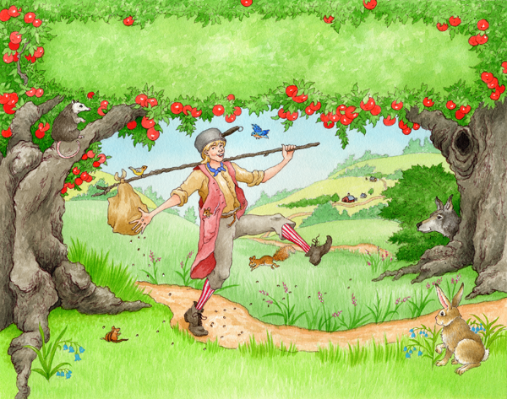
August Theme: All about Me
We will be learning about Johnny Appleseed!
- Colors: Green, Red, Yellow, How to count apples, sorting the colors and learning what patterns are.
- Letter: A, chalk and marker boards. Notebook: writing our names, mastering one letter at a time.
- Number: 1-10
- Crafts: painting apples, apple race game, gluing leaves on trees. Stamping colors, gluing apple seeds.
- Science: I have a fun apple experiment to do with the kids over the course of several days. Also will be taste testing the different apples and seeing which color is their favorite.
- Music and Movement: Johnny Appleseed song, days of the week, A, B, C’s the first week and learning how to hop scotch on our colors.
This isn’t all we will be doing, however my list is way too long to put in here but you get the drift.
I will be getting an idea of some of your children’s favorite things and what they dislike…. I already know many of them!
- Donate: please send in a few magazines that you don’t look at so we can use these for cutting and pasting.
- 1 set of clothes, 2 boxes Kleenex, folder (many have from last year).

